**Docker Volume mounts**

Docker Volume Mount types 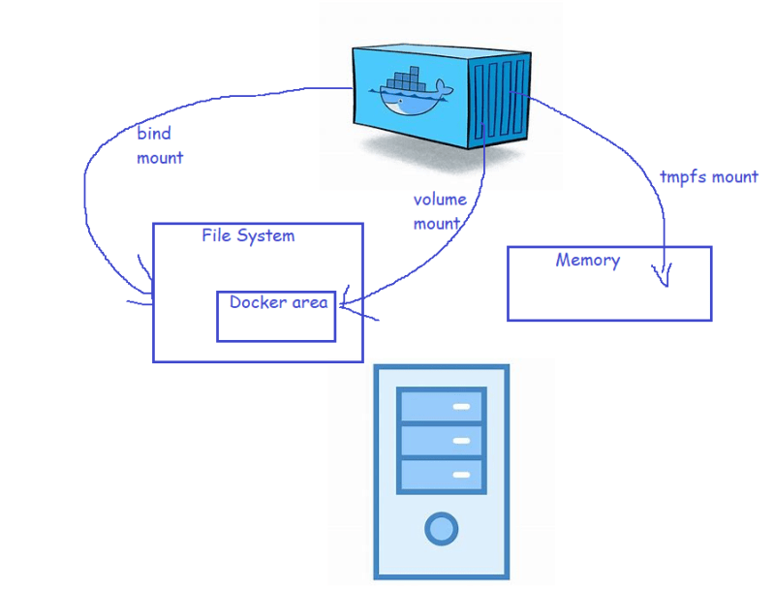

* Lets create a docker volume for the apache html folder 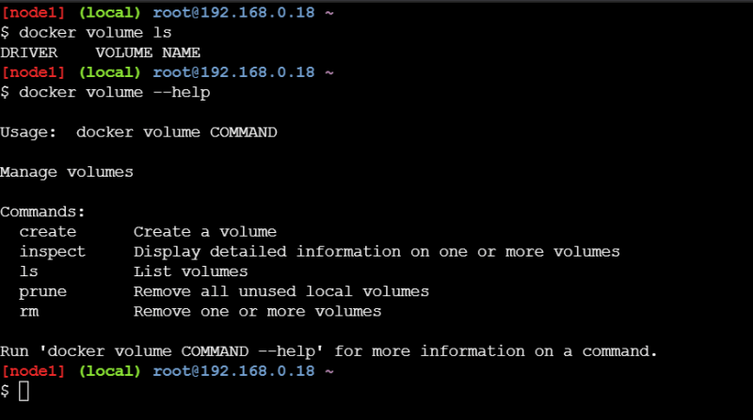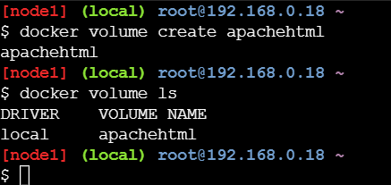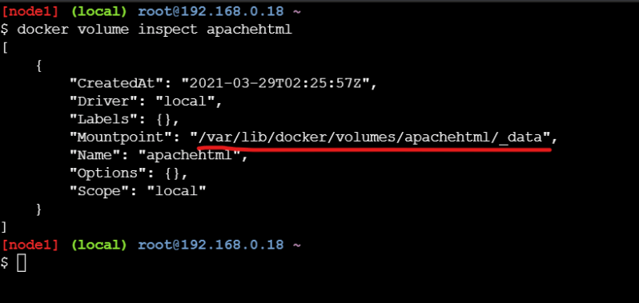
* Start the container with a volume

docker container run -d --name apache1 -P --mount "source=apachehtml,target=/var/www/html" httpd:latest

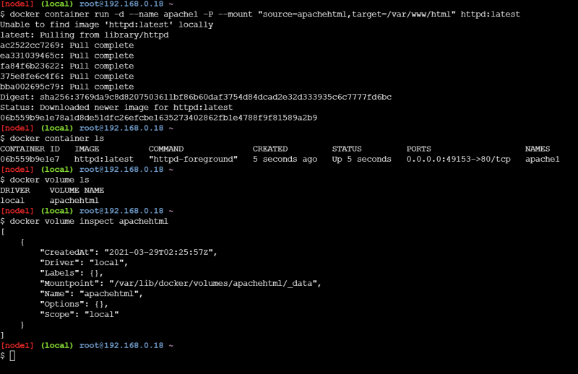

Now lets verify the mount point in the docker container

docker container inspect apache1

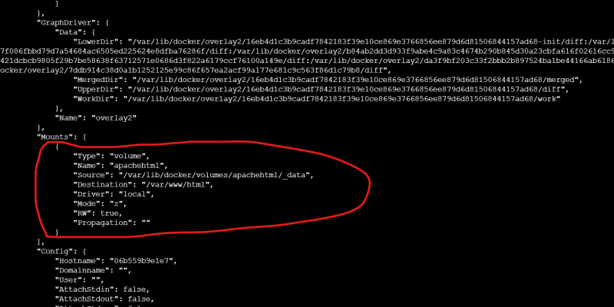

Now lets create some files in the /var/www/html folder from the container 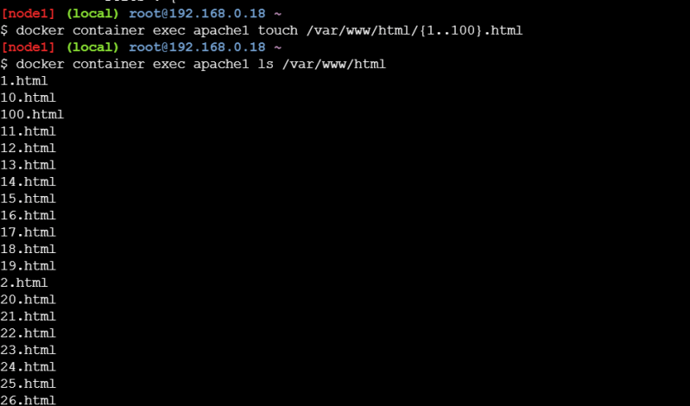

Now let’s create a new container and mount the same volume into same folder (-v)

docker container run -d --name apache2 -P -v 'apachehtml:/var/www/html' httpd:latest

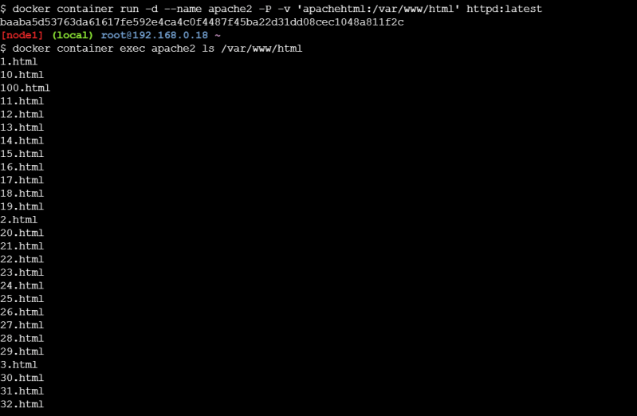

* Now lets delete all the containers

docker container rm -f $(docker container ls -a -q)

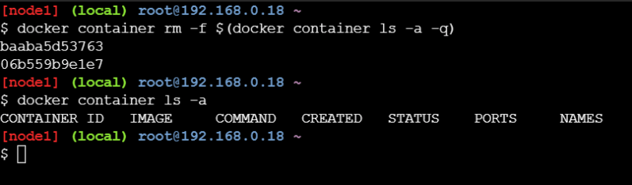

* Now lets create a new container and use the same volume mount

docker container run -d --name apache3 -P --mount "source=apachehtml,target=/var/www/html" httpd:latest

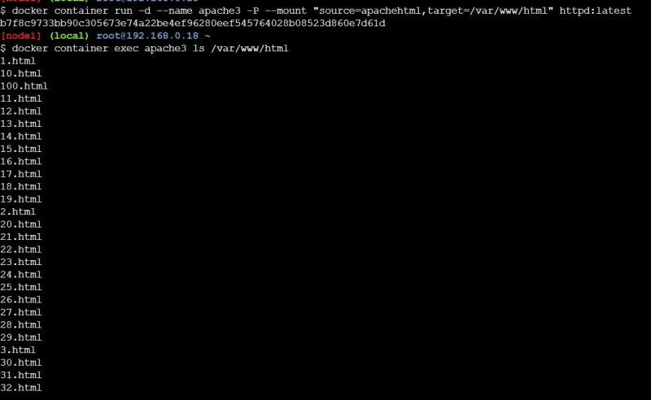

* Volume driver can help in creating volumes in the
  + nfs
  + cifs
  + cloud
* We need to install volume plugins and then use the volume driver while creating the volume
* Lets create a Postgres container with volume mounted so that we can preserve the data(https://hub.docker.com/_/postgres)
* postgres stores the data in the folder /var/lib/postgresql/data
* Lets create a postgres container 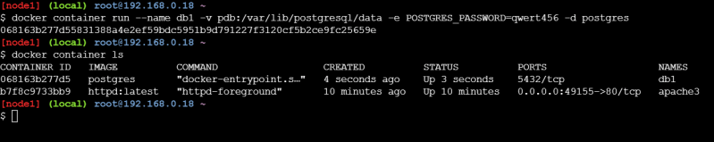
* Now lets use exec command to create some data in the database 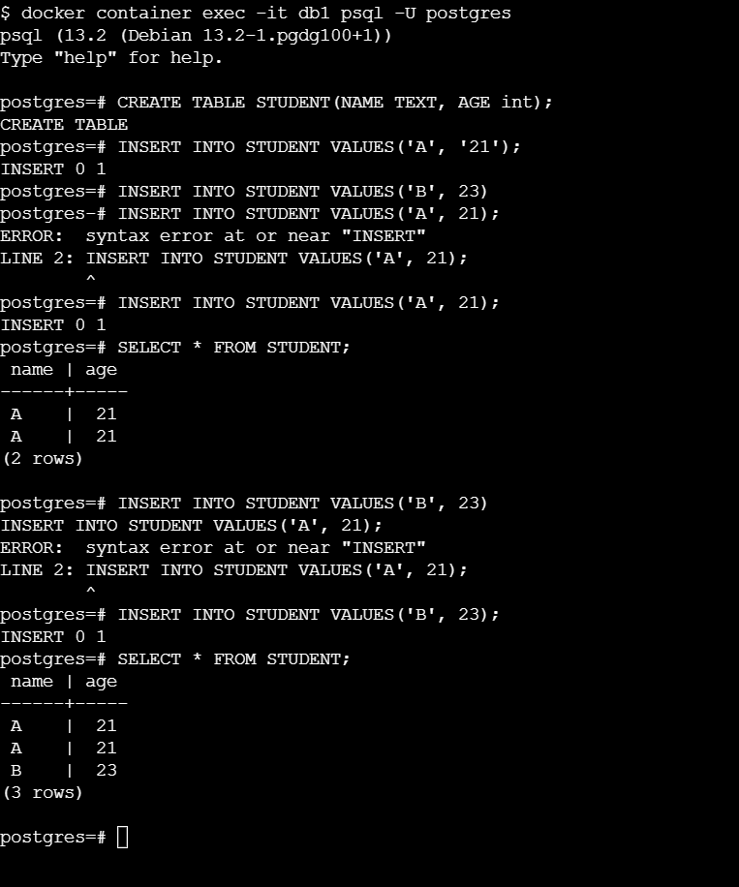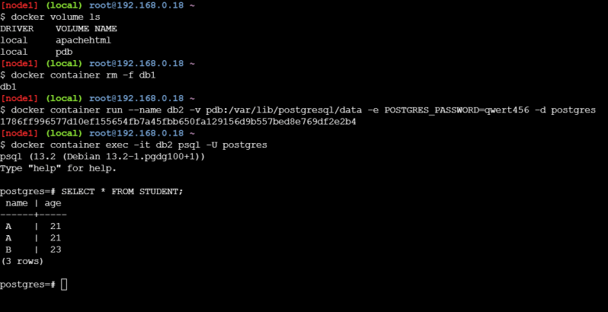
* Containers can run applications of two types
  + Stateless: These applications donot store any data locally, so we dont need volumes for them
  + Stateful: these applications store the data and this data needs to be preserved so for stateful applications we use docker volumes
* Useful docker commands
  + **docker system df**: This command will help in findng out the size of all docker objects in the Host 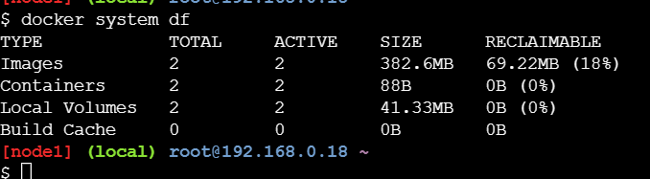
  + To get more detailed information use **docker system df -v** 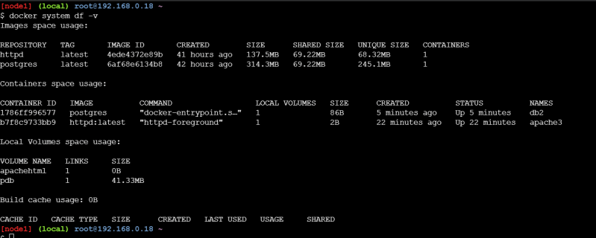
* To view the logs we can use the docker 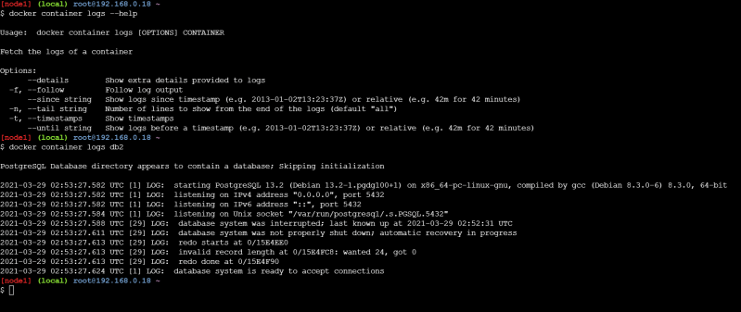
* The other approach of storing logs is create a volume for the /var/logs folder and then export the logs from the docker host to central logs.
* The other approach is to have a log client inside the container running which exports logs to centralized log server.
* For tempfs mount(Link: https://docs.docker.com/storage/tmpfs/)